FULL FEATURED DUAL-RADIO “INSTANT REPEATER”
A NOVEXCOMM EXCLUSIVE; 3U PANEL & CARD
READY TO GO WITH YOUR CHOICE OF RADIO TYPES
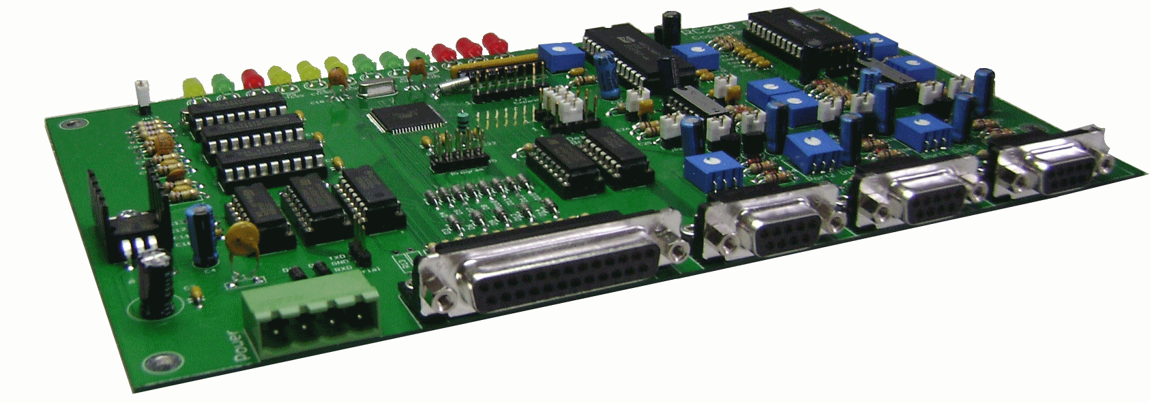
Check out these extensive specifications & order today!
Ports
· Three total - each port may be operated as an independent repeater port or as half/full-duplex link port
· Gated audio on all ports with selectable de-emphasis - you may tap directly off discriminator without regard for squelch action or de-emphasis
· Selectable polarity of COS and CTCSS signals on each port
· Each port has its own unique, programmable hang, timeout, activity, DTMF mute and kerchunk timers
· Selectable CTCSS/Carrier squelch modes (true "AND" operation) on each port
· Selectable CTCSS encode control output with programmable delay dropout for controlling external CTCSS encoder on each port
· Each port has its own dedicated DTMF decoder
· Selectable Enable/Disable of DTMF on each port and selectable mute on 1st or 2nd digit
· Each port may be defined to require CTCSS or not require CTCSS for DTMF operation
· Each port has its own unique 10 courtesy tones with up to 4 segments each (dual tone per segment). Or use a DVR Track or Vocabulary word as a Courtesy Tone
· Any port may be used for a Control Receiver
Site Addressing
· Allows for multiple controller installations to have unique site addresses to maintain common code structure throughout your network.
IDs
· Each port has 3 unique Voice and 2 unique CW ID's.
· Automatic rotation with Initial and Pending ID algorithm
· Programmable Initial and Pending ID timers
· Voice ID's may be disabled on a per port basis for CW only identification
· All IDs may be completely disabled on a per port basis
· ID timers may be selected to start on receiver or transmitter activity
· CW IDs may be programmed with dual or single tones, as well as speed
Linking
· Any port may be linked to any other port on command
· Selectable Monitor Mute/Monitor Mix audio for each port when linked
· Programmable Inactivity timer automatically unlinks ports after a programmable amount of time (may be disabled)
Remote Bases
· Frequency agile HF/VHF/UHF remote base with support for Kenwood, Icom, Yaesu and Doug Hall RBI-1
· Any port may be used
DTMF Memories and Regeneration
· 20 DTMF (50 with optional RTC Module) Memories may be called to send predefined sequence to any combination of Ports
Speech Messages
· Repeater operation oriented vocabulary in real human speech (not synthesized). May be used in programmable ID's or other messages
· 40 Message Macros (70 with optional RTC Module) for easy use of custom programmed phrases
· Any combination of Vocabulary or DVR tracks may be used in any message
· Programmable Tail Messages
Digital Voice Recorder
· On-board DVR for recording your own custom messages (DVR tracks may be used in any programmable message)
Command Macros
· 90 Command Macros for easy one-command functions and may also call other Command Macros for unlimited functionality
· Programmable Pre Access Codes (may be used as Site Prefix Codes). May be disabled completely
· Programmable Macro Subset allows for restricting access to Command Macros. May be disabled completely
· Command Macros may be called by receiver activity (active or inactive)
Scheduler
· Fully automated operations based on time of day and day of week or day of month
Davis Intruments Weather Station Support
· Allows for voice recall of wind, temps and humidity including daily highs and lows
Serial Port
· RS-232 port for use with remote base radios, controller programming and firmware updates
Analog Meters
· 8 analog to digital channels. Each channel is fully scaleable with 6 different meter faces
· Each channel has programmable high and low alarms
· Inputs protected against over or negative voltages
Logic Outputs and Inputs
· 5 digital Alarm inputs which are edge-triggered
· 7 digital outputs may be commanded high/low/pulse. (may be expanded to 32)
Auxilary Audio Inputs
· 3 auxiliary audio inputs for use with a weather receiver, autopatch or other external audio source (may also be used with Alarm Inputs to emulate additional radio ports)
Hardware
· True sine wave microprocessor generated tones
· Use of low-noise, high-impedance JFET op amps for exceptional audio quality
· LED displays of controller status
· Automatic battery backup switchover
· Hardware watchdog timer
· Fan control with programmable shut off timer
Optional Accessories
· Audio delay module
· Battery backed-up Real Time Clock Module (in addition to the onboard one)
· Intelligent Autopatch module
· Windows© programming software
Electrical Specifications
- Microprocessor Atmel ATMega128 RISC microcomputer running at 16 Mhz
- Program Memory 128K Bytes - Flash EEPROM
- Running Memory 4K Bytes Non-Volatile Memory 4K Bytes
- Speech Method ISD 4003 series VoiceCorder© IC
- Logic Inputs: Low < .8 volts High: 5 to 15 volts
- Logic Outputs: 100v @ 500 ma open collector
- Audio Inputs: High impedance >10K
- Audio Outputs: up to 6 volts p-p
- Power Requirement: 11.5 to 15V dc @ 70 ma (LEDs off).
- Operating Temp.: -15 to +55 degrees C (5 to 150 degrees F)
- Connectors: DB-25 analog and digital I/0, Phoenix 4 pin power connector (mating plug included), choice of DB-9 female or RJ45 for radio ports
PRICING AND AVAILABILITY:
3U Panel and tray with any combination of two radio slots: (examples: dual Maxtrac, CDM, XTL, XPR, etc.) with Repeater/ Remote Base card (option –RPT) installed for only $449.95 delivered in the USA.

HAVE YOUR PAYPAL ACCOUNT READY…..
OPERATORS ARE STANDING BY!
ENTERPRISE ELECTRONICS/ NOVEXCOMM.COM
22826 MARIPOSA AVE. TORRANCE CA 90502 310.534.4456
NOVEXCOMM@EEONTHEWEB.COM

